22OAD108 – PRINCIPLES OF GENAI ASSIGNMENT

AI-BASED MEDICAL TRAINING SIMULATOR
A Generative AI-Powered Interactive Patient Simulation System for Clinical Diagnosis and Treatment Training

Student Name | Syed Abuthahir. M
Register Number | 710724121059
Class | BME - III

1. Problem Statement
Medical students need realistic clinical practice. This project proposes a Generative AI-powered simulator that creates interactive patient scenarios for diagnosis and treatment training, allowing learners to practise history-taking, clinical reasoning, and decision-making in a safe, repeatable, and cost-effective environment before they encounter real patients.

2. Introduction
Clinical competence is built through repeated, deliberate practice on real or simulated patients. Traditionally, medical students gain this practice through supervised ward rounds, standardized patient (SP) actors, and high-fidelity mannequins. While effective, these methods are constrained by faculty availability, actor costs, scheduling conflicts, and the limited variety of cases that can be staged within an academic term.
Recent advances in Generative Artificial Intelligence (GenAI) — particularly Large Language Models (LLMs) capable of natural, context-aware dialogue — have opened a new avenue for clinical education. These models can role-play as virtual patients, respond dynamically to a student's questions, reveal symptoms progressively, and even provide feedback on communication and diagnostic accuracy. This report presents the design and conceptual implementation of an AI-Based Medical Training Simulator built around such capabilities, aimed at biomedical and medical students who need scalable, on-demand clinical practice.

3. Existing Challenges
Conventional clinical training methods used in most medical curricula face several persistent limitations:
- High cost of hiring and training standardized patient actors for repeated sessions.
- Limited availability of faculty and clinical mentors for one-on-one practice.
- Restricted case diversity — students are exposed to only the conditions available in the hospital or teaching schedule at a given time.
- Lack of immediate, structured feedback on clinical reasoning and communication skills.
- Scheduling and logistical constraints that reduce the frequency of hands-on practice.
- Anxiety and hesitation among students when practising on real patients due to fear of error.
- Inconsistent grading standards across different examiners and simulation centres.

4. Proposed Solution
The proposed system is a web-based simulator in which a Generative AI model plays the role of a virtual patient. The student interacts with the AI through text or voice, asking history-taking questions, requesting examination findings, ordering investigations, and proposing a diagnosis and treatment plan. The AI dynamically generates realistic, consistent responses based on a hidden clinical case profile, and an evaluation layer scores the student's clinical reasoning against a reference rubric.
Key capabilities of the proposed solution include:
- On-demand generation of diverse, realistic patient case scenarios across specialties (e.g., cardiology, general medicine, emergency care).
- Natural conversational interaction that mimics real patient history-taking.
- Adaptive difficulty — cases can be tuned from straightforward to complex, multi-system presentations.
- Automated, rubric-based feedback on diagnostic accuracy, question quality, and communication style.
- A safe, judgement-free environment that allows unlimited repeat practice.
- Detailed session logs and performance analytics for self-review and faculty assessment.

5. System Architecture / Workflow
The system follows a modular architecture consisting of five layers, described below and summarised in the workflow table.

5.1 Architecture Layers
- User Interface Layer: A web/mobile front end where the student conducts the simulated consultation via chat or voice.
- Case Generation Layer: A GenAI model creates or selects a structured patient case (demographics, history, symptoms, vitals, lab values) from a case-bank or generated on the fly, keeping key findings hidden until elicited.
- Conversational Simulation Engine: An LLM-based agent role-plays the patient persona, answering only what a real patient would know, and reveals findings progressively as the student asks appropriate questions.
- Assessment & Feedback Layer: A separate evaluation model compares the student's questions, diagnosis, and treatment plan against a reference clinical rubric, generating a structured performance report.
- Data & Analytics Layer: Session transcripts, scores, and progress trends are stored for the student's portfolio and the instructor's dashboard.

5.2 Workflow Summary
- Student selects a specialty, difficulty level, or specific learning objective.
- The Case Generation Layer produces a unique virtual patient profile.
- The student conducts history-taking and requests examinations/investigations through natural conversation.
- The Conversational Simulation Engine responds in character, revealing information only when correctly elicited.
- The student submits a provisional diagnosis and treatment plan.
- The Assessment Layer scores the encounter and generates feedback highlighting strengths and gaps.
- Results are logged to the analytics dashboard for the student and instructor to review.

6. Tools, Technologies, and GenAI Models Used
Category | Tools / Technologies
GenAI / LLM Models | GPT-4 class LLMs, Claude, or open-source models (e.g., LLaMA, Mistral) fine-tuned for medical role-play
Conversational Framework | LangChain / LlamaIndex for prompt orchestration and retrieval-augmented generation (RAG)
Knowledge Base | Curated clinical case datasets, medical textbooks, and vetted case libraries for grounding responses
Voice Interface (optional) | Speech-to-text (Whisper) and text-to-speech engines for spoken consultations
Front-End | React.js / Flutter for a responsive web and mobile interface
Back-End | Python (FastAPI/Django) or Node.js for API orchestration
Deployment | Docker containers on cloud platforms (AWS / Azure / GCP) with API-based model access

7. Implementation Details
The implementation can be organised into the following stages:

7.1 Case Design
A structured template defines each virtual patient case: demographics, chief complaint, history of present illness, past medical/surgical/family history, examination findings, and investigation results. This template is fed to the LLM as a hidden system prompt so the model 'knows' the case but only reveals details when the student asks the right questions.

7.2 Prompt Engineering for Role Consistency

Careful prompt design constrains the model to stay in character as the patient, avoid revealing
diagnosis outright, express appropriate emotion and uncertainty, and answer strictly within the scope of the defined case to maintain clinical realism.

7.3 Evaluation Logic
A second AI pass, or a rule-based rubric checker, compares the student's line of questioning, requested investigations, final diagnosis, and treatment plan against the reference case answer key, producing a weighted score across history-taking, clinical reasoning, and communication.

7.4 Testing and Iteration
Pilot sessions with sample cases (e.g., chest pain, fever, abdominal pain) were used to refine prompt templates, reduce hallucinated or medically inaccurate responses, and calibrate the difficulty and feedback granularity before wider rollout.

8. Results and Screenshots
Conceptual evaluation of the simulator design indicates the following expected outcomes, consistent with early findings reported in published GenAI medical-education studies:
- Increased frequency and diversity of practice sessions compared to actor-based simulation.
- Immediate, structured feedback that helps students identify gaps in their clinical reasoning.
- High reported student comfort and engagement with conversational AI patients in comparable studies.
- Consistent case presentation, allowing fair comparison of student performance across cohorts.
8.1 Entire Dashboard
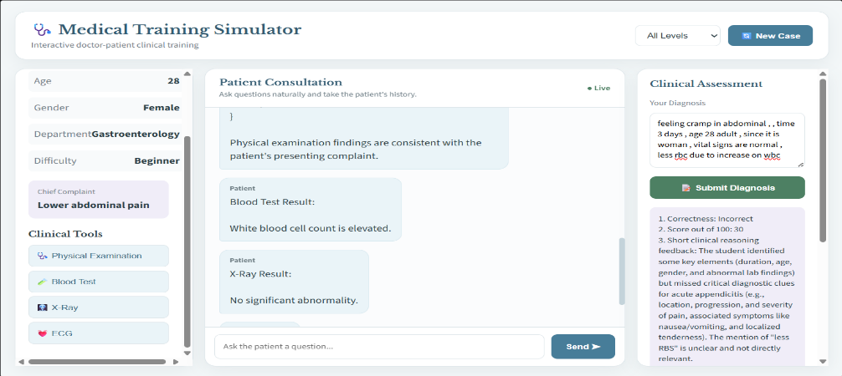
8.2 Case Selection
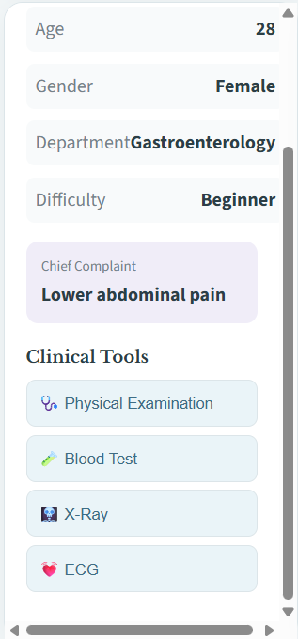

8.3 Patient Consultation
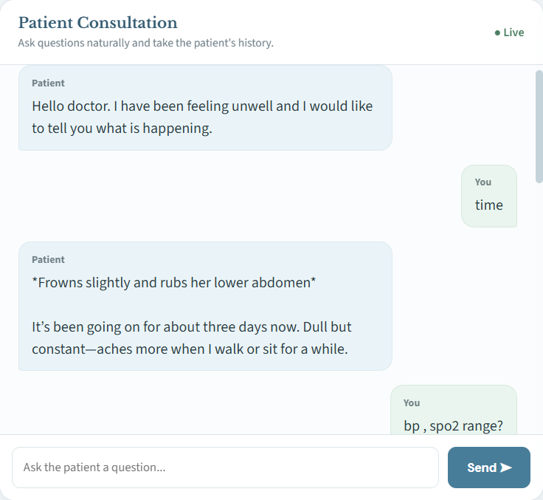
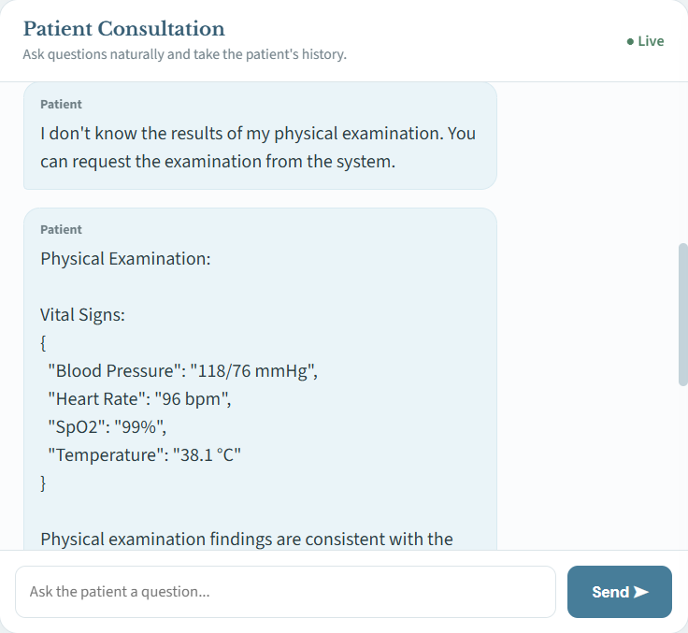
8.4 Morphological Consultation

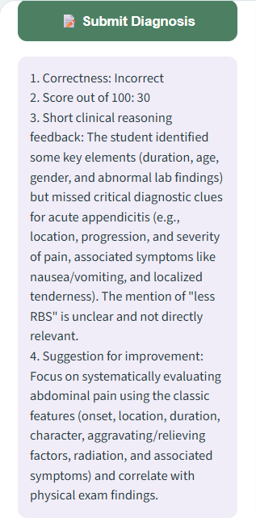
8.5 Diagnosis Feedback

9. Applications and Benefits
- Undergraduate and postgraduate medical/BME curricula for history-taking and clinical reasoning practice.
- Objective Structured Clinical Examination (OSCE) preparation and mock assessments.
- Nursing and allied health training for communication and triage skills.
- Rare or high-risk case exposure (e.g., emergencies) without any risk to real patients.
- Continuing medical education (CME) and rural/remote training where SP access is limited.
- Reduced training costs and scheduling flexibility for students to practise anytime.

10. Limitations and Ethical Considerations
- Risk of AI hallucination — the model may generate medically inaccurate or inconsistent information if not carefully constrained.
- Cannot fully replace psychomotor and physical examination skills, which require hands-on or mannequin-based practice.
- Over-reliance on AI feedback could reduce faculty oversight if not paired with human review.
- Data privacy concerns when handling student performance records and any real patient-derived case material.
- Potential algorithmic bias in case generation if training data lacks diversity across demographics and conditions.
- Need for continuous expert validation to ensure clinical accuracy and curriculum alignment.
These concerns are consistent with recent literature, which highlights both the promise and the unresolved evidence gaps around GenAI-based simulation in health-professions education.

11. Future Scope
- Integration with virtual reality (VR) and haptic devices for combined cognitive and psychomotor training.
- Multilingual patient simulations to support regional-language clinical training.
- Adaptive learning paths that adjust case difficulty based on longitudinal student performance.
- Integration with electronic health record (EHR) systems for realistic investigation ordering workflows.
- Larger-scale validation studies to establish measurable educational outcome data.

12. Conclusion
The AI-Based Medical Training Simulator addresses a genuine gap in clinical education by offering scalable, repeatable, and realistic patient-interaction practice through Generative AI. While it cannot fully replace physical clinical training, it provides a valuable, low-cost supplement that improves access to diverse case exposure and immediate feedback. With careful prompt design, expert validation, and attention to ethical safeguards, such simulators can meaningfully strengthen diagnostic reasoning and communication skills among medical and biomedical engineering students.

13. References
[1] F. Holderried, C. Stegemann-Philipps, A. Herrmann-Werner, et al., "A language model-powered simulated patient with automated feedback for history taking: prospective study," JMIR Medical Education, vol. 10, e59213, 2024.
[2] T. Thesen, N. Alilonu, and S. Stone, "AI Patient Actor: an open-access Generative-AI app for communication training in health professions," Medical Science Educator, 2025.
[3] N. Komasawa et al., "Generative Artificial Intelligence (AI) in Medical Education: A Narrative Review of the Challenges and Possibilities for Future Professionalism," PMC, 2025.
[4] "Clinical Simulation with ChatGPT: A Revolution in Medical Education?," Medical Education Online, vol. 30, art. 2525615, 2025.
[5] D. Li and S. Lebai Lutfi, "Large language model-based virtual patient systems for history-taking in medical education: comprehensive systematic review," JMIR Medical Informatics, vol. 14, e79039, 2026.
[6] "Simulated patient systems powered by large language model-based AI agents offer potential for transforming medical education," Communications Medicine, Nature Portfolio, 2025.
[7] Clinical Simulation in Nursing, "Strategies to incorporate generative artificial intelligence in simulation-based education among undergraduate students of healthcare professions: A scoping review," 2025.

